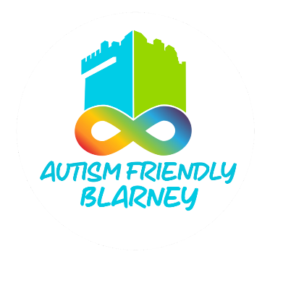

**Suggested Visual Guide Template**

**Garda Station**

Creating a Visual Guide for autistic community members will help them feel prepared and supported.

This is one possible format for images and information you can include, in order.

Ideally, offer the Visual Guide in both digital and printed formats. A digital copy will be uploaded to the AFB website in the resources folder

___________________________________________________________________________

**1. Cover Page**

Image: A welcoming photo of the station exterior, showing the entrance and any signage.

Text Example: “Visiting [Garda Station Name] “This guide will help you know what to do and what to expect when You visit the Garda station.”

**2. Arriving at the Station**

Image: The entrance and/or parking area.

Text: Include information on any relevant parking areas or suggested locations.

**3. Entering the Garda Station**

Image: A photo of the doors or entrance area.

Example text: “You will go through the doors into the station. Mention if the doors are automatic if you need to push them”

**4. Greeting a Garda Member**

Image: A Garda member standing at the front desk, smiling.

Text: “When you go inside, you will see a Garda at the front desk. If the desk is empty – you may need to push the call button [include photo} You can tell them your name and why you are visiting.”

**5. Waiting at the Station**

Image: The waiting area with chairs or a quiet corner.

Text: “If you need to wait, you can sit in the waiting area. You can bring something to keep you calm, like a book or fidget.”

**7. Meeting with a Garda**

Image: A Garda smiling and standing in a private office or meeting room.

Text: “If you need to talk privately, a Garda will meet you and take you to a quiet room to talk. They are there to help you, and you can ask them questions.”

**8. Talking to the Garda Member**

Image: A Garda sitting at a desk, talking to someone.

Text: “The Garda might ask you questions to understand how they can help. You can take your time to answer, and it’s okay to ask for help if you don’t understand.”

**9. Sensory Information**

Image: Symbols for sounds, lights, or busy areas (e.g., sound waves for noise, lightbulb for bright lights).

Text: “The Garda station might be busy, with phones ringing or people talking. If you feel overwhelmed, you can tell the Garda, and they will help you.”

**11. Asking for Help**

Image: A Garda member listening attentively or offering assistance.

Text: “The Garda station is a safe place to go if you need help. Gardai want to help you feel safe.”

**12. Finishing the Visit**

Image: Image of the exit from the inside.

Text: “When your visit is finished, you will leave the station through the same doors.” “You can visit again if You have more questions or need support.”

**Additional Information to Include**

Quiet Times: Mention times when the station is less busy

Contact Information: Provide a phone number or email in case people have questions before arriving.