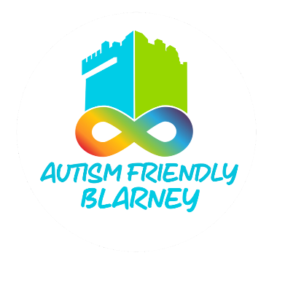

**Suggested Visual Guide Template**

**Fitness Studio**

This is a suggested step-by-step guide to structuring your Visual Guide for autistic customers.

Having this guide will help autistic customers feel more confident and prepared when visiting your studio.

This is one possible format for images and information you can include.

Ideally, offer the Visual Guide in both digital and printed formats. A digital copy will be uploaded to the AFB website in the resources folder

**___________________________________________________________________________________________**

1. **Cover Page**

Image: A photo of the studio’s exterior showing the entrance and signage.

Text Example: “Visiting [Your Fitness Studio Name].”

“This guide will help you know what to do and what to expect when you visit.”

1. **Arriving at the Fitness Studio**

Image: The entrance of the fitness studio, including parking or nearby landmarks for easy identification.

Text Example: “When you arrive, you will see the entrance to the front of the fitness studio.”

“You can park your car [suggestions] and/or walk to the entrance.”

1. **Entering the Fitness Studio**

Image: The entrance doors, possibly showing someone walking in.

Text Example: “You will go through the doors into the fitness studio. The doors might open automatically or make a sound when You walk in.”

1. **Checking In**

Image: The front desk or reception area with a smiling staff member.

Text Example: “When you come inside, you will go to the front desk. You might need to check in with your name or a membership card. The staff are friendly and will help you.”

1. **Exploring the Fitness Studio**

Image: Key areas of the studio, including facilities such as:

Cardio Machines: “This is where you can use machines to exercise.”

Weightlifting Area: “This is where you can lift weights.”

Classroom or Yoga Area: “This is where group classes will happen.”

Changing Rooms: “This is where you can change clothes and store your belongings.”

*Include any specific instructions about these areas the person should know

1. **Sensory Information**

Image: Symbols or icons for sounds, smells, and lights (e.g., sound waves, bright lights).

Text Example: “The fitness studio might be busy with people talking, machines humming, or music playing.”

“There might be smells from equipment or cleaning products. If You feel overwhelmed, you can [options: take a break, use noise-cancelling headphones, quiet area or ask for help].”

1. **Using the Equipment (if applicable)**

Image: Someone using a treadmill or lifting weights with supervision.

Text Example: “When you use the equipment, you can follow the instructions or ask a staff member for help.”

1. **Taking a Class (if applicable)**

Image: A class in session, showing participants and an instructor.

Text Example: “If you join a class, the instructor will show you what to do. You can follow along, and it’s okay to ask questions or rest if you need to.”

1. **Staying Safe**

Image: Safety features, such as a staff member helping someone or cleaning equipment.

Text Example: “It’s important to use the equipment safely and listen to the staff. If you need help, you can ask a staff member or a trainer.”

1. **Taking Breaks**

Image: A quiet corner, water fountain, or lounge area.

Text Example: “If you feel tired or need a break, you can sit down and rest. You can drink water to stay hydrated.”

1. **Finishing Your Visit**

Image: A person leaving the studio, smiling or waving.

Text Example: “When You are finished, you can leave the studio through the same doors.”

**Additional Information to Include**

Quiet Times: Mention times when the studio is less busy and quieter.

Special Accommodations: Highlight any sensory-friendly options (e.g., quiet areas, modified classes).

Contact Information: Provide phone numbers or emails for questions or to request accommodations.

Specific information about equipment, set up, classes or facilities.