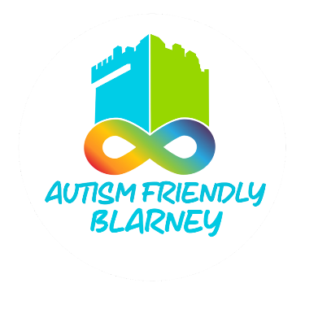

**Suggested Visual Guide Template**

**Retail**

This is a suggested step-by-step guide to structuring your Visual Guide for autistic customers.

Having this guide will help autistic customers feel more confident and prepared when visiting your shop.

This is one possible format for images and information you can include.

Ideally, offer the Visual Guide in both digital and printed formats. A digital copy will be uploaded to the AFB website in the resources folder

___________________________________________________________________________

**1. Cover Page**

Image: A welcoming photo of your shop's exterior, showing the entrance and any signage.

Text Example: “Visiting [Your Shop Name] This guide will help you know what to do and what to expect when you visit our shop.”

**2. Arriving at the Shop**

Image: The entrance or parking area.

Text: Include information on any relevant parking areas or suggested locations to park.

**3. Entering the Shop**

Image: A photo of the automatic doors or entrance area.

Example text: “You will go through the doors into the shop. The doors are automatic and will make a sound when they open.”

**4. Seeing the Staff**

Image: Smiling staff members in uniforms or name tags.

Example text: “You might see staff who are here to help. They will be happy to see you and can answer your questions.”

**6. The Shop Layout**

Image: An overview of the shop or key areas, like aisles, checkout counters, or signs. A general map with categories and areas can be useful.

Text: “Inside the shop, you will see aisles with items for sale.” “You can look at the signs to find what you need.” Include information about different floors and how to access them, if relevant to your shop.

**7. Shopping**

Image: A customer with a shopping basket or trolley.

Text: “You can take a basket or trolley to carry your items.” “You can take your time and walk through the shop to find what You need.”

**8. Sensory Information**

Image: Symbols for sounds (e.g., sound waves), lights, or crowds.

Text: Include any relevant noises specific to your shop, if you play music, optional quiet times if you provide them. Mention if you have a sensory kit available to borrow if needed. Include information on bright overhead or flashing lighting, or any dark areas if relevant. Also note aisles that aisles with fridges and freezers are colder, can make continuous noise.

**9. Asking for Help**

Image: A staff member assisting a customer.

Text: “If You can’t find something, you can ask a staff member for help. You can use your preferred method of communication and our staff will do their best to help you.”

**10. Checking Out**

Image: The checkout counter, showing both self-checkout and staffed options.

Text: “When you are done shopping, you can go to the checkout counter.” “You can pay with cash, card, or [other payment options].”

**11. Leaving the Shop**

Image: The shop entrance from inside, showing the way out.

Text: “After you pay, you can return your basket or trolley and leave the shop through the same doors you came in.”

**Additional Information to Include**

Toilets: Indicate if there are customer toilets available

Quiet Times: If your shop has specific hours when it’s less busy, mention them.

Quiet Spaces: Indicate if there’s a spot to sit or take a break.

Contact Information: Provide a phone number or email for questions or accommodations.